Requesting Support
- Email support@adelaidecloud.net
Please add a brief description of your problem and contact details.
The ticket system will automatically reply with your request number.

Escalating a support request
- Email escalate@adelaidecloud.net
Please put your ticket request number in the Email Subject and place your contact details in the message body.

Emergency Escalation
- Please call (08) 8132 7350 and ask to speak to the Service Delivery Manager.

Sales or Orders
- Email sales@adelaideCloud.net or orders@adelaidecloud.net
One of our sales team will get back to you with your quote or order details.

Out of Hours
- Telephone (08) 8132 7319
Please note this is for emergencies only and non-emergencies may be charged at an enhanced time and materials rate.

- Adelaide Cloud Ticket Logging Assistance

- Are the lights on and Green? Is everything plugged in?

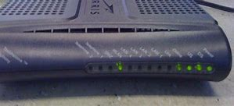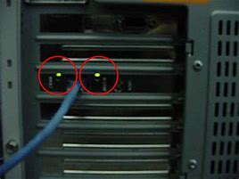

- Do you have internet or other applications working?

- Has something changed?

- It may sound daft…

